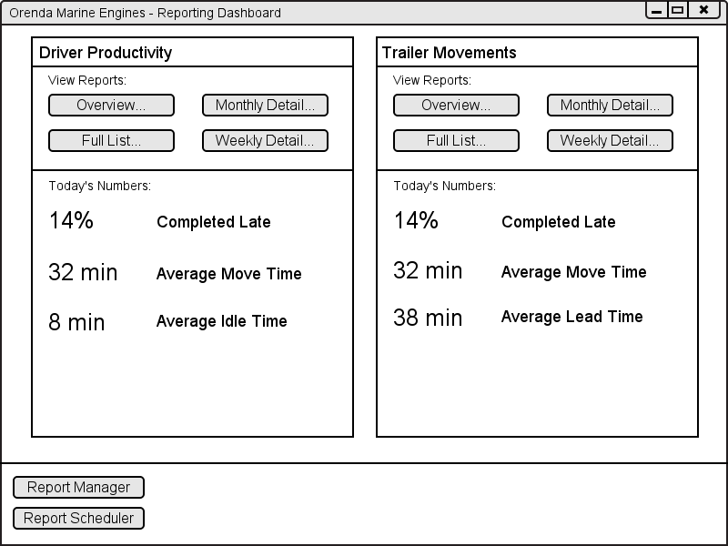

20

21

22

23

24

25

26

27

28

5 6 16 17 18 19

14

15

1

2

3

4

7

8

9

10

11

12

13

|  |  |  |  |
| --- | --- | --- | --- |
| # | Type | Text | Functions/Notes |
| 1 | Label | Driver Productivity | Report Title |
| 2 | Label | View Reports: |  |
| 3 | Button | Overview… | Brings up dialog to select reporting period, and to run or schedule report.  This report shows the overall statistics for all drivers selected in the time period selected. |
| 4 | Button | Full List… | Brings up dialog to select reporting period, and to run or schedule report.  This report shows all moves for the selected driver for the reporting period, subtotalled by week and month. |
| 5 | Button | Monthly Detail… | Brings up dialog to select reporting period, and to run or schedule report.  This report shows the average statistics for a selected driver by month, subtotalled by year. |
| 6 | Button | Weekly Detail… | Brings up dialog to select reporting period, and to run or schedule report.  This report shows the average statistics for a selected driver by week, subtotalled by month and year. |
| 7 | Label | Today’s Numbers: |  |
| 8 | Live Statistic Label | <Varies> | This label updates periodically based on live data. |
| 9 | Label | Completed Late |  |
| 10 | Live Statistic Label | <Varies> | This label updates periodically based on live data. |
| 11 | Label | Average Move Time |  |
| 12 | Live Statistic Label | <Varies> | This label updates periodically based on live data. |
| 13 | Label | Average Idle Time |  |
| 14 | Button | Report Manager | This button brings up the Report Manager screen, allowing the user to customize what is displayed on the dashboard, and other options associated with the reports. |
| 15 | Button | Report Scheduler | This button brings up the Report Scheduler screen, allowing the user to manage scheduled reports, add/update/remove/etc. |
| 16 | Label | Trailer Movements |  |
| 17 | Label | View Reports: |  |
| 18 | Button | Overview… | Brings up dialog to select reporting period, and to run or schedule report.  This report shows the overall statistics for all four docks in the time period selected. |
| 19 | Button | Full List… | Brings up dialog to select reporting period, and to run or schedule report.  This report shows all moves to and from a specific dock for the reporting period, subtotalled by week and month. |
| 20 | Button | Monthly Detail… | Brings up dialog to select reporting period, and to run or schedule report.  This report shows the average statistics for a specific dock by month, subtotalled by year. |
| 21 | Button | Weekly Detail… | Brings up dialog to select reporting period, and to run or schedule report.  This report shows the average statistics for a specific dock by week, subtotalled by month and year. |
| 22 | Label | Today’s Numbers: |  |
| 23 | Live Statistic Label | <Varies> | This label updates periodically based on live data. |
| 24 | Label | Completed Late |  |
| 25 | Label | Average Move Time |  |
| 26 | Live Statistic Label | <Varies> | This label updates periodically based on live data. |
| 27 | Label | Average Lead Time |  |
| 28 | Live Statistic Label | <Varies> | This label updates periodically based on live data. |

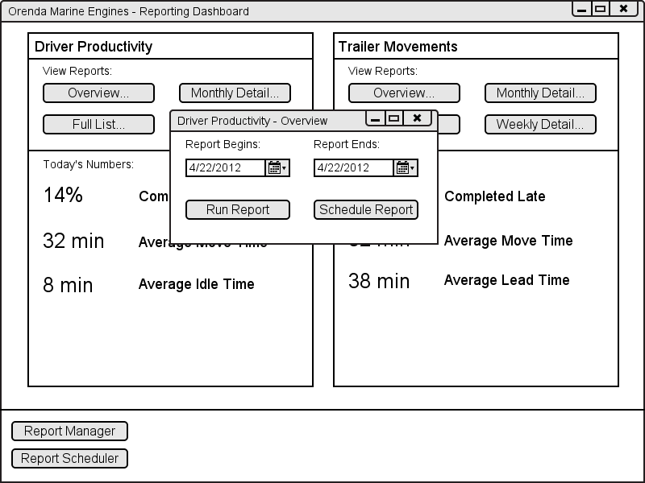

4

5

6

1

2

3

|  |  |  |  |
| --- | --- | --- | --- |
| # | Type | Text | Functions/Notes |
| 1 | Label | Report Begins |  |
| 2 | Date Picker | <Date> | The user can choose a date for the beginning of the reporting period. |
| 3 | Button | Run Report | This button runs the report. It takes the parameters input and brings the user to the report detail screen. |
| 4 | Label | Report Ends |  |
| 5 | Date Picker | <Date> | The user can choose a date for the ending of the reporting period. |
| 6 | Button | Schedule Report | This button brings up the report scheduling dialog. It takes these parameters, and allows the user to schedule a report. |

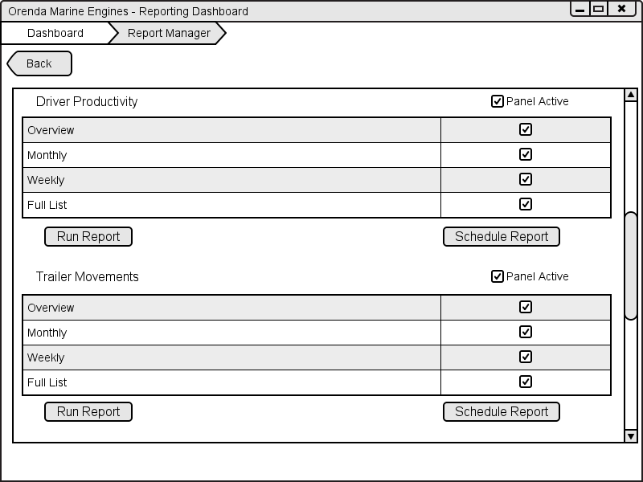

15

16

17

18

19

20

1

2

3

4

5

6

7

8

9

10

11

12

13

14

|  |  |  |  |
| --- | --- | --- | --- |
| # | Type | Text | Functions/Notes |
| 1 | Breadcrumb Menu | Dashboard > Report Manager | The user can click on the relevant breadcrumb and be brought back to that view. |
| 2 | Button | Back | Brings the user back one page. |
| 3 | Label | Driver Productivity |  |
| 4 | Label | Overview |  |
| 5 | Label | Monthly |  |
| 6 | Label | Weekly |  |
| 7 | Label | Full List |  |
| 8 | Button | Run Report | Runs the selected report for that subsection. |
| 9 | Label | Trailer Movements |  |
| 10 | Label | Overview |  |
| 11 | Label | Monthly |  |
| 12 | Label | Weekly |  |
| 13 | Label | Full List |  |
| 14 | Button | Run Report | Runs the selected report for that subsection. |
| 15 | Check box | Panel Active | Determines if the panel containing that report is visible from the dashboard |
| 16 | Check boxes |  | Determines if each corresponding report is available to be run. |
| 17 | Button | Schedule Report | Brings up the report scheduling dialog, and allows the user to schedule a report. |
| 18 | Check box | Panel Active | Determines if the panel containing that report is visible from the dashboard |
| 19 | Check Boxes |  | Determines if each corresponding report is available to be run. |
| 20 | Button | Schedule Report | Brings up the report scheduling dialog, and allows the user to schedule a report. |

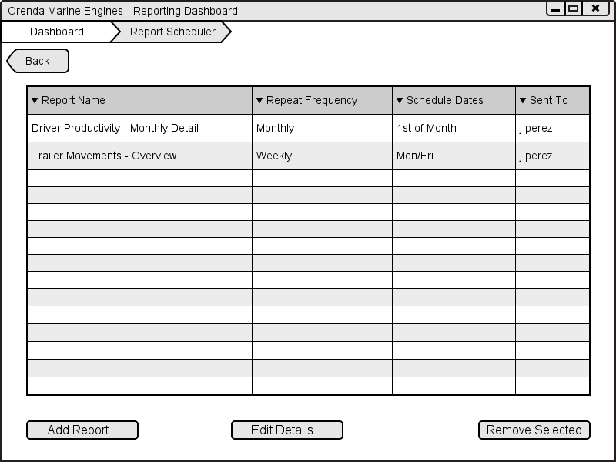

8

9

7

4 5 6

1

2

3

|  |  |  |  |
| --- | --- | --- | --- |
| # | Type | Text | Functions/Notes |
| 1 | Breadcrumb Menu | Dashboard > Report Scheduler | The user can click on the relevant breadcrumb and be brought back to that view. |
| 2 | Button | Back | Brings the user back one page. |
| 3 | Grid Column | Report Name | Displays the title of the report. If clicked, sorts alphabetically. |
| 4 | Grid Column | Repeat Frequency | Shows how often the report is repeated. |
| 5 | Grid Column | Schedule Dates | Shows the relative dates or days of the week that the report is scheduled for. |
| 6 | Grid Column | Sent To | Shows the user IDs of who the report gets sent to. |
| 7 | Button | Add Report… | Opens up the add report dialog, allowing the user to schedule a report. |
| 8 | Button | Edit Details… | Opens the edit report dialog. Essentially the add report dialog, but with the selected report details prepopulated. |
| 9 | Button | Remove Selected | Removes the selected report from the schedule. |

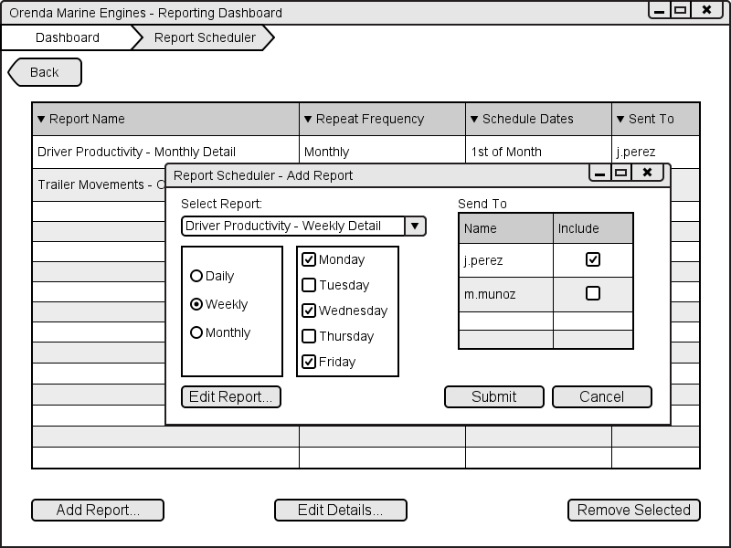

6

7

8

9

1

2

3

4

5

|  |  |  |  |
| --- | --- | --- | --- |
| # | Type | Text | Functions/Notes |
| 1 | Label | Select Report |  |
| 2 | Combobox | <Varies – Report names> | Combobox of all available reports, arranged in a tree structure |
| 3 | Radio Buttons | Daily/Weekly/Monthly | Repeating period for the report, changes the controls in #4. |
| 4 | Check Boxes or Date picker | <Varies – Dates, weekdays, or times> | Varies depending on #3, lets the user pick the days, times, or dates that the report will send in the repeating period. |
| 5 | Button | Edit Report… | Brings the user to a modified Report view, where they can select filters for the scheduled report. |
| 6 | Label | Send To |  |
| 7 | Check Boxes | <Varies – User Names> | Lists the usernames of anyone with permission to receive the report. |
| 8 | Button | Submit | Closes the dialog, and saves the scheduled report to the system. |
| 9 | Button | Cancel | Closes the dialog, and does not save the report. |

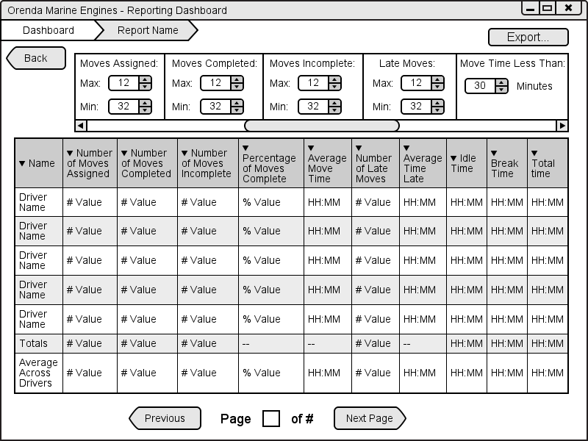

6

1

2

3

4

5

|  |  |  |  |
| --- | --- | --- | --- |
| # | Type | Text | Functions/Notes |
| 1 | Breadcrumb Menu | Dashboard > <Report Name> | The user can click on the relevant breadcrumb and be brought back to that view. |
| 2 | Button | Back | Brings the user back one page. |
| 3 | Filter Panel | <Varies> | Depending on the report, there will be a list of relevant filters and selection criteria. Each column on the report and each parameter will have a default value, but they will be all searchable, selectable, and modifiable. |
| 4 | Report View | <Varies> | Column-based view of the chosen report, columns vary depending on report chosen. |
| 5 | Page Selection | Previous, Page <Current> of <Total>, Next | Page selection, shows the current page, the total number of pages, and buttons for the next and previous page (disabled if at start or end). The current page is also a text entry field, to allow the user to jump to any given page at will. |
| 6 | Button | Export… | Brings up a dialog for export options, including printing, and exporting as a file (XLS, PDF, etc). |